**CSA1086 - Software Engineering**

Scrum Board

Step 1: Create a Scrum Project

* Log in to Jira and click on Projects > Create Project.
* Choose Scrum Template and click Next.
* Name your project (e.g., "News Website Development") and configure the settings as needed.

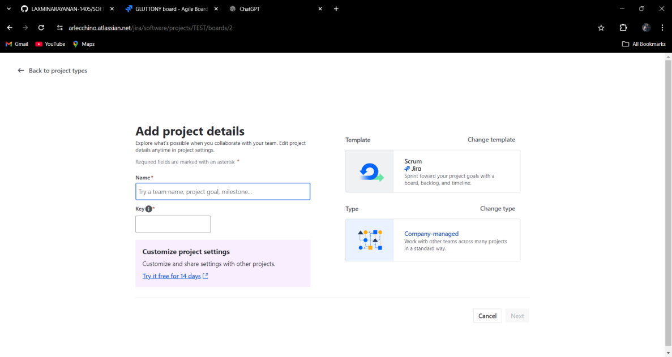

Step 2: Add Epics

* Go to the Backlog View and enable the Epic Panel:
* Click on the three-dot menu ("...") > Show Epic Panel.
* Click + Create Epic in the Epic Panel.
* Fill in the details for each epic:
* Epic Name: Example: "Frontend Design" or "Backend Development".
* Summary: A brief summary of the epic's goal.

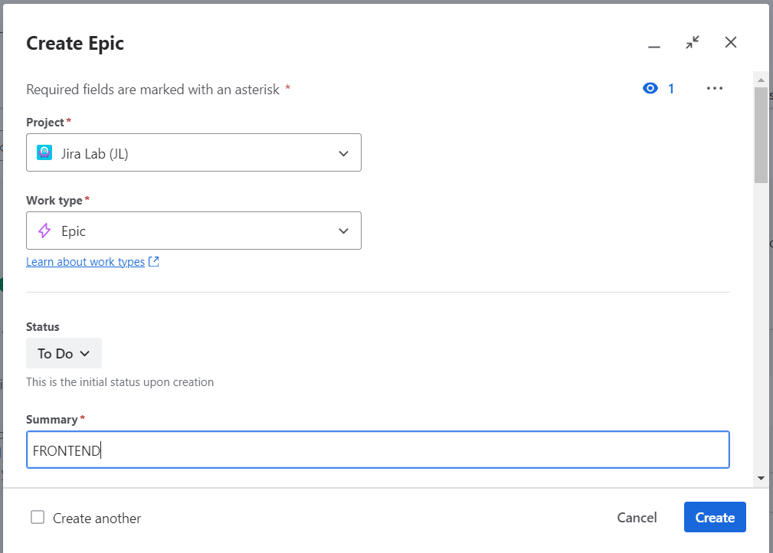

Step 3: Create Stories and Link to Epics

* In the Backlog View, click Create Issue and select Story as the issue type.
* Fill in the story details:
* Summary: Example: "Build the Website Structure."
* Description: Add specific tasks to complete the story.
* Epic Link: Link the story to its epic using the dropdown menu.
* Save the story and repeat for all stories.

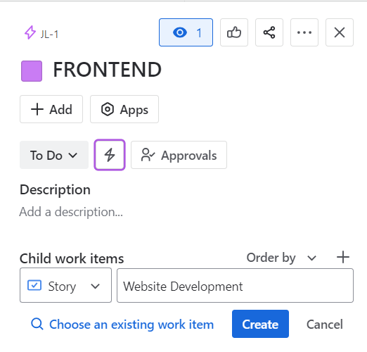

Step 4: Create a Sprint

* In the Backlog View, click + Create Sprint.
* Add backlog items (stories) to the sprint by dragging them into the sprint section.
* Name the sprint and set the duration (e.g., 1 week).
* Click Start Sprint to begin.

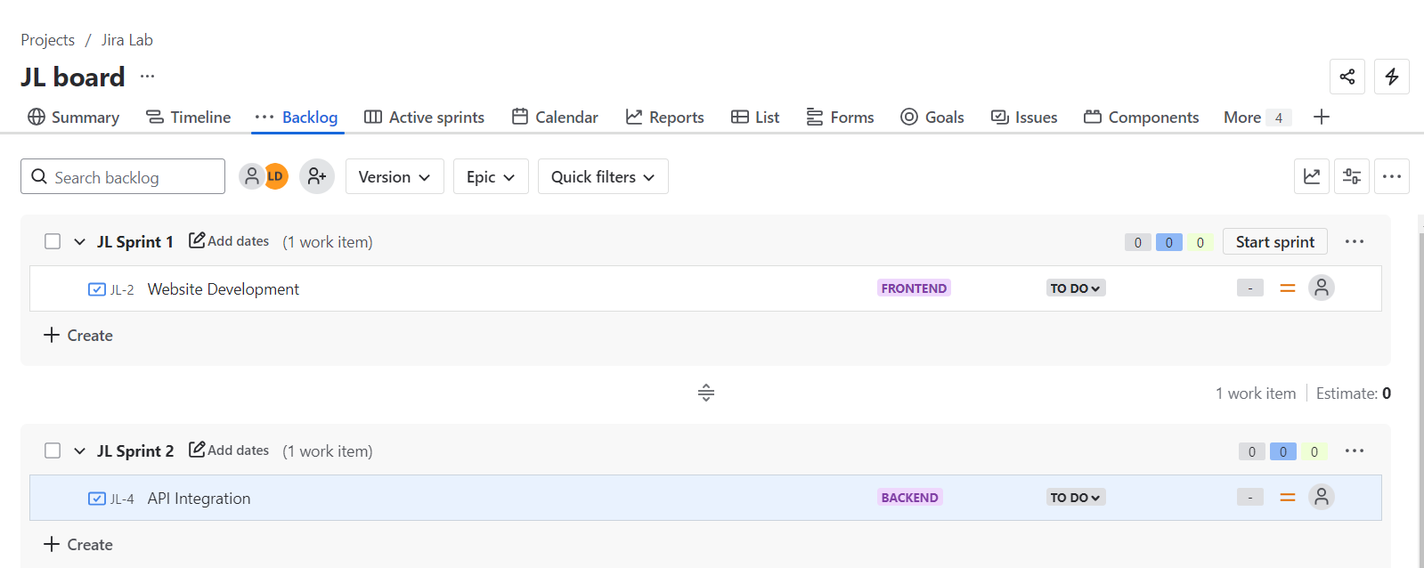

Step 5: Track Progress

* Navigate to the Active Sprint View.
* Drag stories from To Do to In Progress and finally to Done as they progress.
* Use the Burndown Chart to monitor progress and ensure the sprint stays on track.

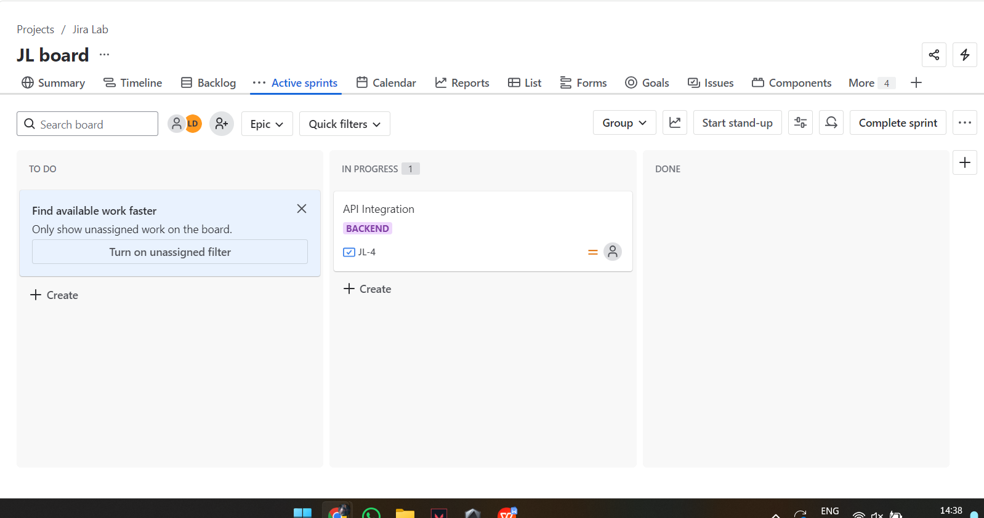

Step 6: Sprint Completion

* At the end of the sprint, click Complete Sprint.
* Review unfinished stories and decide whether to move them to the next sprint or the backlog

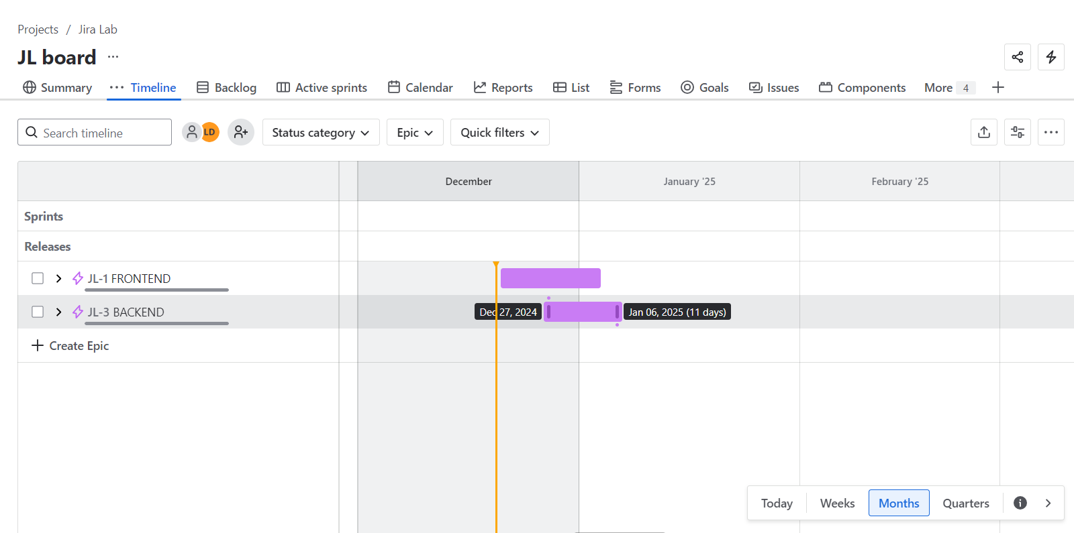

By:

S.Vignesh

192325002